Triangle
LT-3 Line Tester Operator’s Guide
Version 1.0, including Flex-piping
Revised March 29th, 2014

Table of Content

System Description

Safety & Concerns

Limitations

Pictures

Setup

Procedure for Steel & Fiberglass Line Types

Procedure for Flexible Line Types

Calculating Results

Results Form

After Testing

System Description:

The Triangle LT-3, Version 1.0 including Flex-piping product line tester is a volumetric constant pressure hydrostatic line testing system. It is designed to test steel, fiberglass, plastic, and flexible pipe and lines. For special line materials, products, or pressures, please call Triangle to discuss before conducting test (800) 767-6004.

The LT-3 has two testing cylinders capable of test two lines at a time. The lines can of different types, steel, fiberglass, plastic or flex. For blended products test both blended product lines at the same time to eliminate bleed through and false alarms.

For steel or fiberglass rigid lines we require a 150% of pump pressure, 50 psi minimum pressurized fifteen (15) minute minimum waiting period and a fifteen (15) minute data collection test period.

For plastic or flexible lines we require a 150% of pump pressure plus 10 psi, 60 psi minimum pressurized fifteen (15) minute line stretch period, a 150% of pump pressure, 50 psi minimum pressurized thirty (30) minute minimum waiting period, and a fifteen (15) minute data collection test period.

Basic concept:
Steel & Fiberglass,
- Connect LT-3 to line or lines to be tested,
- Pressure line to 150% of pump pressure, minimum 50 psi,
- Wait fifteen (15) minutes minimum, no maximum, for stabilization,
- Record start pressure, time, level, temperature,
- Wait fifteen (15) minutes, no more or less,
- Record end time, level, temperature,
- Calculate results,

Plastic & Flex,
- Connect LT-3 to line or lines to be tested,
- Pressure line to 150% plus 10 psi of pump pressure, minimum 60 psi,
- Wait fifteen (15) minutes no more or less for stretch,
- Pressure line to 150% of pump pressure, minimum 50 psi,
- Wait thirty (30) minutes minimum, no maximum, for stabilization,
- Record start pressure, time, level, temperature,
- Wait fifteen (15) minutes, no more or less,
- Record end time, level, temperature,
- Calculate results,
Safety & Concerns:
Safety First!
Secure site, lockout/tagout equipment, wear PPE, fire extinguisher, absorbent pads, etc.,

Inert dry nitrogen must be used.
Nitrogen must be provided using a double stage regulator.
Maximum test pressure must not exceed 100 psi.
The Stainless Steel plug on the top of the reservoir must be slightly leaking during testing.
A leak has a consistent rate per hour, temperature and line stretch do not.
Time cures both temperature and stretch issues.
A net positive leak is not possible at 50 psi or above, check your setup and procedures.
Monitor fluid level during “waiting time” to make sure there isn’t a large leak in system.

Limitations:
Product is gasoline, diesel, aviation fuel, fuel oil, or other liquid as approved my manufacturer.
Line material is steel, fiberglass, flex pipe or other as approved by manufacturer.
Test is conducted at 150% of turbine pressure or 50 psi minimum whichever is greater.
Maximum test pressure is 100 psi as restricted by the manufacturer.
Maximum line size is 6” diameter and 110 gallons volume.
- 110 gallons in a 1” line equals 2,400 feet
- 110 gallons in a 2” line equals 640 feet
- 110 gallons in a 3” line equals 288 feet
- 110 gallons in a 4” line equals 164 feet
- 110 gallons in a 5” line equals 105 feet
- 110 gallons in a 6” line equals 73 feet

Maximum thermal change is 4 degrees F per hour during the test.
Line stretch time is fifteen (15) minutes.
Waiting time is minimum or more fifteen (15) minutes, no maximum.
Test period is fifteen (15) minutes.
Gauges and sensors must be working properly and verified or calibrated semi-annually.

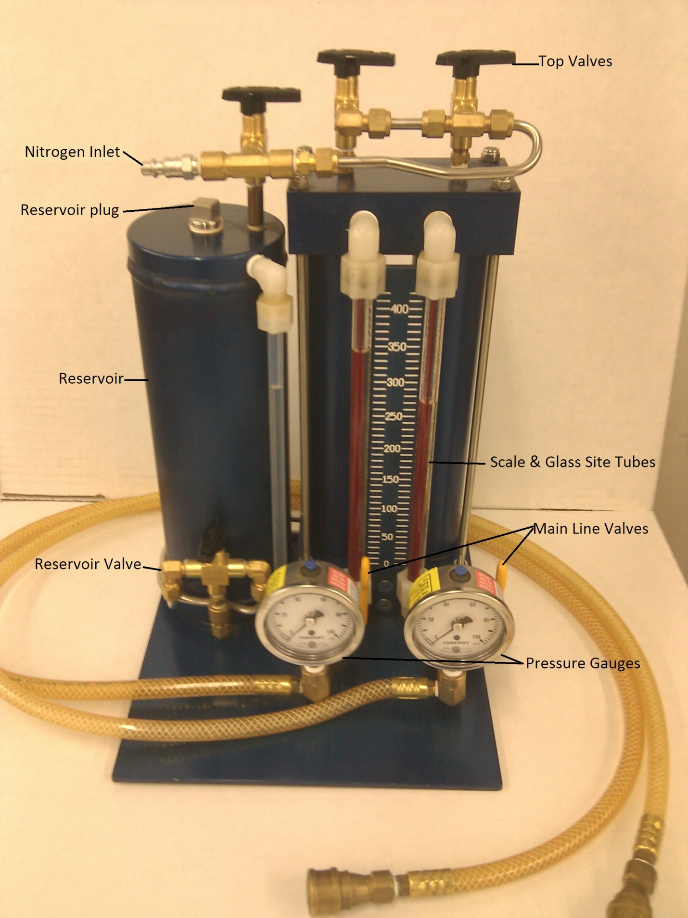

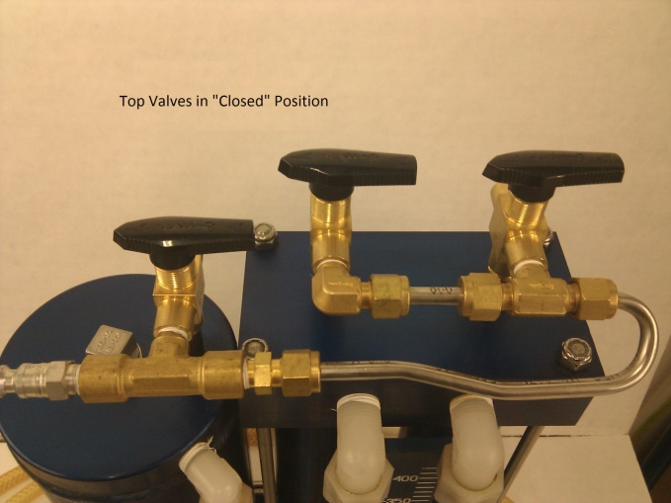 Top Valves in “Closed” Position
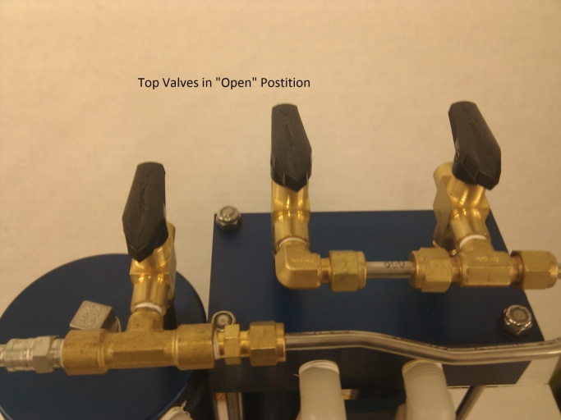 Top Valves in “Open” Position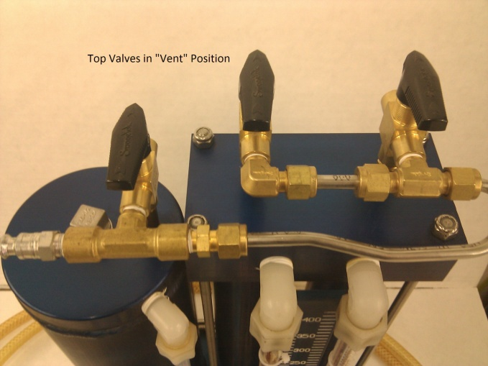 Top Valves in “Vent” Position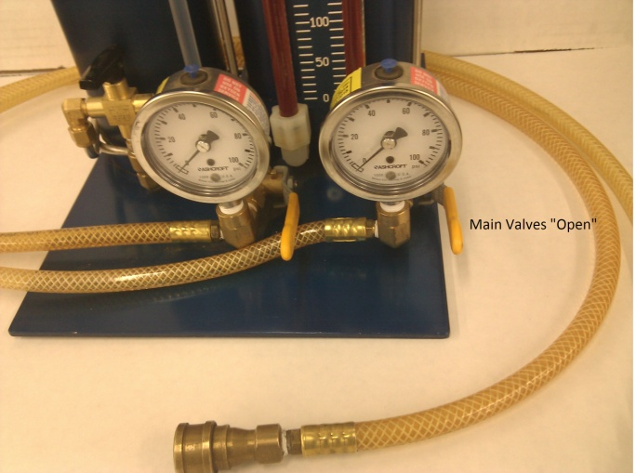 Main Valves in “Open” position
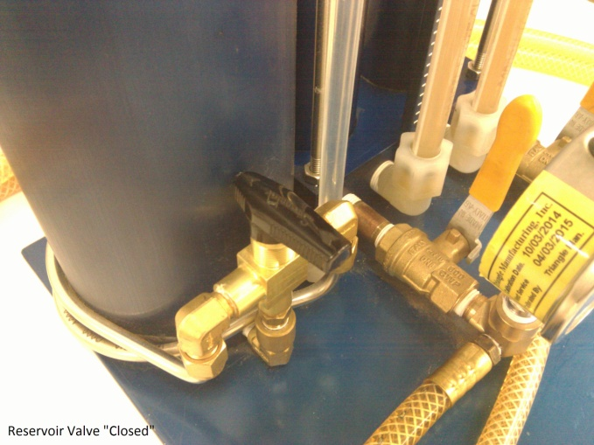 Reservoir Valve in “Closed” position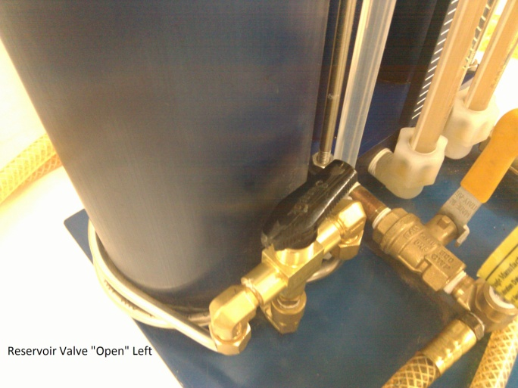 Reservoir Valve in “Open Left” position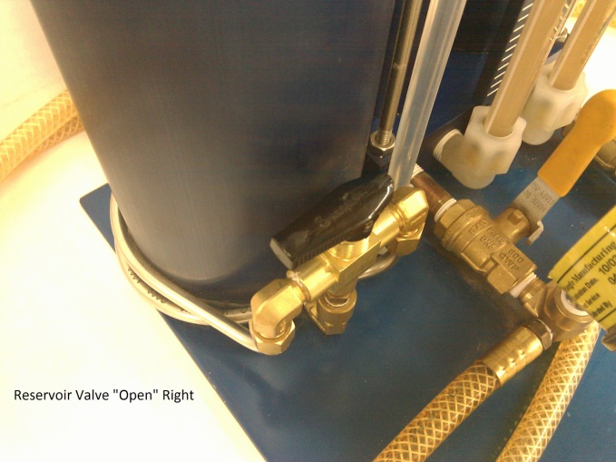 Reservoir Valve in “Open Right” position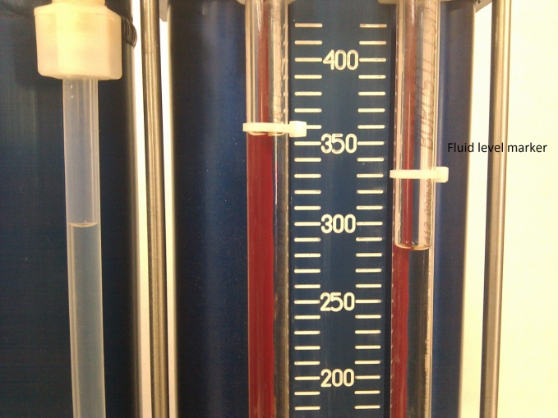 Glass site tubes and level markers

Setup:
Confirm limitations are met as listed above. Call Triangle if not sure (800) 767-6004.
Remove line pressure, Isolate line, turbine, dispensers, etc,
Fill tester reservoir and cylinders with product,
Install test adaptor to line to be tested,
Close all six (6) valves on tester, connect tester to adaptor,
Set nitrogen regulator to 50 psi or above as calculated for 150% of turbine pressure,
Connect nitrogen hose to LT-3 tester,
“Open” all top valves to point forward to pressurize cylinders and reservoir,
“Open” lower reservoir valve to point left or right to pressurize left or right cylinder,
Slowly “Open” main line valve to pressurize line,

Steel & Fiberglass line types:
50 psi
Set nitrogen regulator to 50 psi or above as calculated for 150% of turbine pressure,
After fifteen (15) minutes,
“Close” lower reservoir valve to point forward,
“Mark” the fluid level using fluid level marker on the site glass,
Start test:
Record test start time, level, and temperature,
After fifteen (15) minutes, record test end time, level, and temperature,
Complete calculations for final results.

“Pass” is 0.05gph or less. “Fail” is 0.051gph or more.

Flexible line types:
60 psi
Set nitrogen regulator to 60 psi or above as calculated for 150% of turbine pressure plus 10 psi,
After fifteen (15) minutes,
Set nitrogen regulator to 50 psi or above as calculated for 150% of turbine pressure,
After thirty (30) minutes,
“Close” lower reservoir valve to point forward,
“Mark” the fluid level using fluid level marker on the site glass,
Start test:
Record test start time, level, and temperature,
After fifteen (15) minutes, record test end time, level, and temperature,
Complete calculations for final results.

“Pass” is 0.05gph or less. “Fail” is 0.051gph or more.
Results:
CFR = Corrected Final Result (gph).
LC = Level Change (ml) in fifteen minutes.
TC = Temperature change (F) in fifteen minutes.
V = Volume of line in gallons.
COE = Coefficient of thermal expansion (gasoline 0.0007 g/degree F), (diesel 0.00045 g/degree F)

CFR = (LC/946) - (TC*4*V*COE)

Example #1, When the temperature is going up then you would subtract the temperature value from the ml value.
LC = 53 ml/15 minutes
TC = +0.2 F/15 minutes
V = 53 gallons
COF = 0.0007 g/F
CFR = (53/946) - (0.2*4*53*0.0007) = (0.0560) - (0.0297) = (0.0560) - (0.0297) = +0.0263 gph

Example #2, When the temperature is going down then you would add the temperature value to the ml value. ( to minus a negative equals a positive)
LC = -23 ml/15 minutes
TC = -0.2 F/15 minutes
V = 53 gallons
COF = 0.0007 g/F
CFR = (-23/946)-(-0.2*4*53*0.0007) = (-0.0243)-(-0.0297) = (-0.0243)+(0.0297) = +0.0054 gph

“Pass” is 0.05gph or less. “Fail” is 0.051gph or more.

After testing:
“Close” all valves on tester,
Remove nitrogen hose,
“Vent” three top valves to point back position (Vented)
“Close” both top valves on cylinders to point sideways position (Closed)
“Open” lower reservoir valve to point left to de-pressurize left cylinder,
Slowly “Open” left main line valve to de-pressurize left line,
“Open” lower reservoir valve to point right to de-pressurize right cylinder,
Slowly “Open” right main line valve to de-pressurize right line,
“Close” all valves on tester,
Disconnect hose connector from adaptor.
Remove adaptor, and install impact valve plug.
Remove isolation devices, lockout/tagout devices and return station to operational mode.
Confirm facility operates properly.
Make sure there are no leaks from impact plugs.
Open facility.
Done

